Data Sharing in a Pandemic Citizens’ Juries
Jury 2 of 3 (Greater Manchester) - April 2021
Jurors’ Report

A report produced with the 18 members of the jury of adults from Greater Manchester assessing the future of data sharing initiatives introduced in response to the Covid-19 pandemic
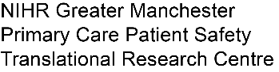
April 15 2021

Commissioned by:

Designed and delivered by:

Table of Contents
1. Preface 3
About this report 3
1. Statement to Commissioning Bodies, Policymakers and Public 4
2. The jury questions and the jury’s answers 6
2.1 Data Sharing Initiative: Summary Care Record Additional Information 6
Q1 How supportive are you of the decision to introduce this data sharing initiative in 2020 as part of tackling the COVID-19 outbreak? 6
Q2 What should the future of the data sharing initiative be? 7
2.2 Data Sharing Initiative: NHS Covid-19 Data Store and Platform 9
Q1 How supportive are you of the decision to introduce this data sharing initiative in 2020 as part of tackling the COVID-19 outbreak? 9
Q2 What should the future of the data sharing initiative be? 10
2.3 Data Sharing Initiative: Early Warning System 11
Q1a How supportive are you of the decision to introduce this data sharing initiative in 2020 as part of tackling the COVID-19 outbreak? 11
Q2a: For how long should the initiative continue? 12
2.4 Data Sharing Initiative: Immunisation and Vaccination Management Capability 12
Q1a How supportive are you of the decision to introduce this data sharing initiative in 2020 as part of tackling the COVID-19 outbreak? 12
Q2a: For how long should the initiative continue? 13
2.5 Data Sharing Initiative: OpenSAFELY and its access to GP data 13
Q1 How supportive are you of the decision to introduce this data sharing initiative in 2020 as part of tackling the COVID-19 outbreak? 13
Q2 What should the future of the data sharing initiative be? 14
2.6 Lessons learned for the future 16
Q3 What lessons could be learned for the future? 16
3. The jury process: what we heard and did 17
Jury Day 1: Context setting 17
Jury Day 2: Background information 17
Jury Day 3: Summary Care Record Additional Information 18
Jury Day 4: NHS Covid-19 Data Store and Platform 19
Jury Day 5: Early Warning System and Immunisation and Vaccination Management Capability 20
Jury Day 6: OpenSAFELY 22
Jury Day 7: Jury Deliberations 23
Jury Day 8: Deliberation and report writing (this report) 23
Appendix A: Messages to our neighbours 24
Appendix B: The jury questions 26

Preface

About this report

This is a report from the 18 members of the citizens’ jury who met online over eight afternoons between 6 and 15 April 2021 to hear evidence from a wide variety of witnesses, to deliberate together, and to make recommendations. 18 jury members drawn from a cross-section of adults across Greater Manchester were recruited. It was the second of a set of three citizens’ juries on data sharing in a pandemic commissioned by the University of Manchester (with funding from the National Institute for Health Research Applied Research Collaborative), NHSX (part of NHS England and NHS Improvement), and the NHS National Data Guardian’s Office. The first jury was held in March (consisting of jurors from all of England) and the third jury will be held in April and May with jurors drawn from across West and East Sussex.
This report was constructed using the words of the 18 jury members, using statements they prepared together. A draft version was reviewed and agreed by jury members as part of the jury process on 15 April before being reformatted, and distributed to members of the jury.
A Juries’ Report about all three juries with additional information (e.g. on jury recruitment) will be produced by Citizens Juries c.i.c. and published online in June 2021. Other materials including presenters’ slides will also be published online.

Statements to Commissioning Bodies, Policymakers and Public

At the conclusion of the jury, participants chose to share the following about their experience and collective work assessing the pandemic data sharing initiatives and their future:

Statement to Neighbours

I think it is important to know that everyone's voice has been heard and captured throughout the whole process and it has been conducted in a fair and unbiased manner.
It was intense with a lot of information to process quickly but I enjoyed working with new people and discussing an important topic
This was amazingly informative and a well-run experience. I will miss the discussions with the people I have met over the two weeks.
This process has been really interesting and I feel quite privileged to have been invited onto this jury.
The experience has been enlightening, informative and really comfortable. It’s been an opportunity to learn more about the subject area with neutral and then persuasive arguments so that you can form your own opinions and share and develop them through deliberation with others. The way it has been set up and the people who have been in the space have made it a really enjoyable experience that I'd definitely recommend that others should try.
The Citizens’ Jury was a unique opportunity to discuss an important topic with several people I would never normally interact with on a day-to-day basis. I am usually quite opinionated and it was interesting to see experts’ conflicting ideas around the individual topics and often very difficult to pick between one side or another.
It's important to know that the jury was very structured in terms of the informative presentations and deliberations that followed, which allowed for optimal uptake of the information. It was very interactive as we discussed with each other, but also got the chance to write down our own thoughts we may not have shared. I also thought it was very useful for us to be able to ask questions to those witnesses delivering presentations.
It has been such an eye-opening experience, which I feel lucky to be a part of, especially
with it relating to the current pandemic. Each presentation made valid points as well as raising concerns which made you analyse all of the information. It was nice, after so long, to interact with people, albeit online. Sarah, Kyle and the rest of the team have done an amazing job of the planning and the running of the online dury.
My experience as a juror has been so informative. I have learned a lot about the different ways our data has been used during the pandemic. I also learned a lot by listening to my colleagues’ insights on different topics. During my experience, I have changed my mind a lot after different discussions. It's been such an amazing experience and I am very glad I was able to take part.
The process allows you to express your opinions on the matter and hear other peoples’ views. It also gives you the opportunity to change your views and the views of others.
The jury is very professionally run and lots of help is available from people who know what they are doing, so no need to be anxious about taking part, falling behind or having technical problems that you won't be able to overcome.
There's a lot of information to take on board through the presentations but this has been run so efficiently, I've learnt a lot; it's superior to my time in University lectures! Kyle, Sarah and Malcolm, all the observers and guests have made the process so smooth and accommodating. The other jurors are lovely people and were extremely polite, making sure everyone's voice is heard. I've not once felt intimidated, unsure or not heard throughout deliberations thanks to the way it's been run over Zoom, with the breakout rooms and the jurors themselves. I've really enjoyed hearing people's different opinions. I would love to do another one and I will recommend my friends/family do, too!
It is important for my family, friends, and peers to know that the whole experience was enjoyable and enlightening. The process was well scripted and the presentations were well informed. I can now tell others about certain data platforms and give a little more feedback about data sharing. The other jurors were very friendly. We all had our own thoughts and talking them over in small groups enabled us to think outside the box. I thought that the whole process would be long-winded but the time was proportioned equally, in between presentations and group chats. If I had the chance to do another Citizens’ Jury I would not hesitate to apply.
This experience has exceeded my expectations. I was inquisitive to work with a group that I knew would have a broader view than me and would encourage me to be more open-minded. I have been surprised by the number of times I have changed my mind after deliberations with others, particularly the young. It has been a privilege to have contact with the 'expert witnesses' and more importantly to have the chance to hear both sides of the questions and ask questions of the presenters. It has awoken my brain and I would encourage anyone to apply and participate. It has been fascinating. Using Zoom and working with excellent facilitators in Sarah and Kyle makes me note that Management and Board meetings in Industry could learn a lot from this kind of DELIBERATION!
First of all I think it is important for my family friends and neighbours to know that organisations like Citizens’ Juries do exist in the UK and that we can participate in shaping our democratic process by taking part in them. I would also like to tell them how simple the process was to take part in and that everybody on the jury was respectful of each other's views and the whole process was very collaborative even when we as jurors had different views. Much of that was down to Kyle introducing the process as being about deliberation and not debate. Although the subject matter was quite detailed, the well thought-out format broke it down into manageable sessions with plenty of breaks. The "Expert Witnesses" were also good and stimulating presenters. All in all a good support to the democratic process.
This Citizens’ Jury has been a valuable experience. We have been informed about how, during the Covid-19 pandemic, certain laws had been changed without public notification and extended every three months. This was called a COPI (control of patient information) notice and it will be revised again in September 21. Our medical data, if you weren't already aware, is privy to being shared for the purpose of faster access to our record with the intention of providing better health care. Research has taken place from this data and without the COPI notice the researcher called open Safely wouldn't have had access to this data so freely, yet decisions made from this research/data have been invaluable in saving lives. Our jury has been asked to vote on how we feel data should be shared and whether or not it is for the best interest of following the “five safes,” as well as what will change after the pandemic for the better, fair and unbiased manor, basically feels as though the public opinion matters, and hopefully our voice can be heard on a wider scale. The American democratic process working with Manchester University has been so well thought through and very well planned. I feel privileged to have taken part.
I have been fortunate enough to be selected to take part in another Citizens’ Jury and I feel that I learnt a great deal about data sharing in a pandemic. The hosts have been amazing putting it all together and making it very slick and everything has seemed to run smoothly and on time without any kind of technical issues. I have enjoyed chatting and liaising with other members of the jury. We have had some good, intense discussions and put our arguments both for and against. The whole process has gone very quickly and I hope that as a group we can stay connected.

Statement to Commissioners and the Public

I feel the work we have done over the past two weeks has been extremely valuable as the lay person would not normally have the opportunity to hear such in depth presentations from experts that handle their data.
it a chance for you to get involved in the democratic process have a voice and express your opinions in matters that count
I think it is important to know that each initiative was presented in a fair and easy to understand way and as a jury we were given time to gather our thoughts, deliberate and examine the evidence and question the presenters. The start to finish process has been conducted by the Center for New Democratic Processes in a fair and constructive manner and Kyle and Sarah have been excellent at running the Jury.
Over the past two weeks, we've received neutral presentations from different professionals about a certain data topic. We've discussed these topics between us and expressed our point of view. We document our reason to support or oppose each initiative.
It is important to know that we have been fully informed of exactly how these initiatives have been created, why they were compiled and how they have been used to help during the pandemic. By having multiple guest speakers from different companies, not just the NHS and with working as teams in the breakout rooms it has broadened my horizons on how our personal data is used and what should happen going forward, legally and ethically.
After spending two weeks learning more about health data sharing I think it's important that the public get behind Ednas of Gtr Manchesters idea to suggest that all bodies produce information telling us - 'THIS IS WHAT WE KNOW ABOUT YOU.' and that we might also ask about who the "WE" is 😉
It is important that everyone had the chance to listen to a variety of presentations on a variety of data sharing subjects. We had the chance to put our views across, deliberate, change our mind if we wanted to, it was nice to meet people from all different backgrounds but lived within our local community.
it's important for everyone to know that as a group we have listened to all the arguments for and against, discussed everything in detail and asked lots of questions before coming up with our conclusions
It's been very informative because it was led by organisers and we were shown presentations by those who work in the field. It is not a topic I have ever thought about before but clearly it has much more depth than I knew. I have enjoyed learning about it with people who also have had no prior knowledge about it as it was a fun, informative collective experience
The public should be aware that as a mixed jury that represents the wider population, we have all been well informed through fair, neutral and persuasive presentations that have allowed us to deliberate and come to a general consensus that data sharing initiatives can be extremely beneficial for many reasons if consensual, safe and transparent.
I think it's important for those involved in the pandemic sharing initiatives & public because sharing & having access on a wider scale can benefit everyone giving them an insight to how these processes come together & can be beneficial to all.
It's important to know that many expert views have been put forward to us, the organising of experts from all sides of the debate was well structured. As lay people we had good opportunities to debate and question these experts after which we all were able to give our opinion by debate and in writing.
Reassuringly I never felt any question or debate was not relevant.
I think it important for those involved in the Pandemic Data Sharing Initiative to know that although most of us are broadly supportive of the Initiatives and we appreciate the hard work done we do have some serious concerns about security now and we are also concerned about the future of COPI. From the public's point of view I would like to tell them about what we have learnt and that if we want to know about how decisions on the sharing of Health Data we need to be more proactive because the government, the NHS and other health organisations are not good at keeping us informed about data sharing.
It's important for the wider public to understand what has changed regarding their data and privacy during the pandemic and potentially beyond. They will hopefully be reassured to learn that as a diverse group of regular citizens, we have been presented with all the facts and scrutinised the methods and have come to a consensus through a democratic process of how these initiatives should proceed where the priorities of the people are paramount.
A Citizens Jury of 18 people consisting of a cross section of pe0ple within Greater Manchester came together for 8 days to consider Pandemic Data Sharing that has occured during COVID19 and the possible continuation when the Pandemic is over. Expert witnesses delivered presentations both in support and opposition and the Jury were permitted to deliberate both in small groups and full jury to reach conclusions.
Outside of the specific questions this form of Public Consultation may reassure and eliminate concern regarding the security and the sharing of patients’ data.
For anyone involved in the Pandemic Data Sharing Initiatives I would ask that they keep in mind that not everyone is aware of websites that contain information regarding Data Sharing, and maybe more promotions based around this can be looked into. It is important that you build trust with the general public and you could do this by being honest, fair and lawful.
The public should take into consideration that the NHS had to make a decision about data sharing rapidly and this saved lives and helped researchers get vaccines produced and rolled out quickly so we as a nation can get back to some kind of normality!!
The pandemic has created a distorted world for us. The work of the jury represents a chance for the public to further their understanding of the issues such as data sharing that have been instrumental in working to mitigate some of the impact of covid. Politicians and scientists, however, must be made aware that the public are stakeholders and that they must be held to account at every instance.

The jury questions and the jury’s answers

The questions for the citizens’ jury, and our answers/recommendations are set out below. The jury questions are in italics. Our answers explain, in our own words, what we thought about the pandemic data initiatives we considered. We voted to prioritise what we considered to be most important of our ideas, and the numbers of votes are shown throughout section 2 (often votes exceed 18 in total because we were given more than one vote each).
This section begins with jury questions (see Appendix A) and answers about the jury’s three pandemic data sharing initiative case studies, and two sub-case studies (both of which are products within the NHS Covid-19 Data Store and Platform):
- Summary Care Record additional information
- NHS Covid-19 Data Store and Platform
  - Early Warning System sub-case study
  - The Immunisation and Vaccination Management Capability sub-case study
  - OpenSAFELY and its access to GP data
We had fewer questions to answer about the two sub-case studies and consequently less time to consider them (half a day each).
At the end of this section of the report are our answers to further questions about lessons learned for future pandemics.
The process we went through to reach our conclusions is described in section 3.

Data Sharing Initiative: Summary Care Record Additional Information

The data initiative being considered here is the extraction of “additional information” from over 50 million computerised patient records held in general practices’ (GPs’) computer records into the Summary Care Records for those patients held on the national “Spine”. The Summary Care Record is used to view information (including the additional information) about a patient by those providing care. Prior to the pandemic this additional information was only uploaded into a patient’s Summary Care Record with the patient’s express consent. In Spring 2020 the data from GP records was added without asking patients in order to assist with patient care during the pandemic. The initiative was a direct response to a direction within the COPI Notices issued in 2020 (subsequently renewed until September 2021).

Question 1 asks how supportive we are of the decision to introduce the data sharing initiative in Spring 2020. We voted on the multiple choice question (Q1a).

Q1 How supportive are you of the decision to introduce this data sharing initiative in 2020 as part of tackling the COVID-19 outbreak?

Answer choices | Responses | Percentage
Very much in support | 8 | 44.5%
Broadly supportive | 8 | 44.5%
Neutral | 2 | 11%
Broadly opposed | 0 | 0%
Very much opposed | 0 | 0%
TOTAL | 18 | 100%

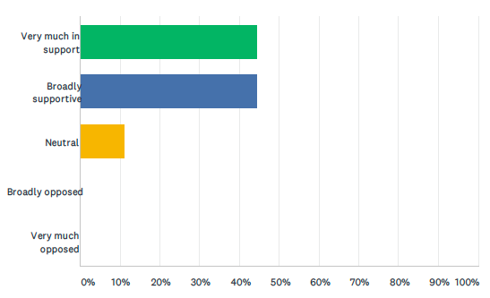

We also identified and prioritised our reasons to support (Q1b) and oppose (Q1c) the data sharing initiative.

Reasons to Support - Summary Care Record (Additional Information)
The Summary Care Record Additional Information can provide useful information to healthcare professionals, particularly in emergency situations and when an individual is unable to communicate with them directly. - 16 votes
Additional information in the Summary Care Record can help to make better, more informed and faster decisions about patient care which improves care and can help save lives. - 15 votes
The Additional Information contains information that is valuable to researchers and could support improved research after the pandemic. - 8 votes
The Summary Care Record Additional Information can assist with planning and commissioning of future healthcare services (such as the integration of health and social care). - 7 votes
The Additional Information has provided useful information for policymaking and decisions to respond to the pandemic. - 4 votes
Growing awareness of the SCR Additional Information will allow people to make more informed choices about whether to opt-in or opt-out. - 4 votes

Reasons to Oppose - Summary Care Record (Additional Information)
The initial lack of transparency and inadequate communications about the Summary Care Record Additional Information could result in lack of awareness or decreased trust among the public. - 16 votes
People were not given the opportunity to provide explicit consent and many people may be unaware of what information is stored about them, with whom it is shared, and how to opt out of the Summary Care Record due to the changes resulting from COVID response and COPI notices. - 10 votes
The Summary Care Record Additional Information may end up being used for non-COVID response purposes (such as commercial exploitation) which is not the original intent of the initiative. - 9 votes
The Summary Care Record Additional Information increases the information available as well as the need for enhanced security to protect personally identifiable data and records from being inappropriately accessed or shared due to many access points. - 8 votes
Vulnerable populations may not be aware of what information is stored about them, how it is shared, how to access it, and how to opt out. - 7 votes
The vast majority of additional information that is included due to extending or enhancing the Summary Care Record (up to 75%) may not actually be used or utilised. - 4 votes

Q2 What should the future of the data sharing initiative be?

We heard arguments from witnesses and then voted on two multiple choice questions about what we believe should be the future of the Summary Care Record Additional Information data sharing initiative. The witness speaking in support of the initiative argued that the initiative should continue for as long as it is valuable, and that the decision should be made by the organisation accountable for the initiative (informed by patients and other stakeholders). We heard from the challenge witness (Phil Booth from medConfidential) that the initiative should only continue as long as the pandemic continues, and that the decision should be made by an independent advisory group of experts and lay people.

Q2a: For how long should the initiative continue?

Answer choices | Responses | Percentage
As short a time as possible | 0 | 0%
Only as long as the Covid pandemic continues and emergency powers are in place | 5 | 28%
As long as it is valuable (potentially beyond the pandemic and for Covid and non-Covid uses) | 10 | 55%
Something else | 3 | 17%
TOTAL | 18 | 100%

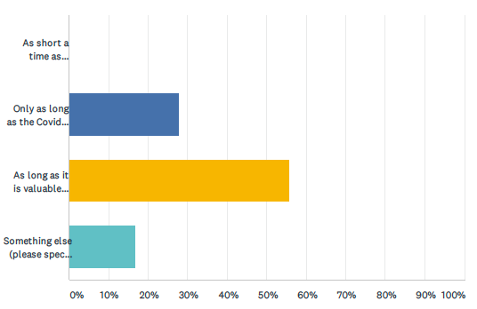

When voting on this question in the online questionnaire, we were each asked to give a brief reason for our answer. Reasons will be analysed and reported in the Juries’ Report in June.

Q2b: By whom should these decisions be made?

Answer choices | Responses | Percentage
An independent advisory group of experts and lay people | 17 | 95%
The minister or organisation accountable for the data initiative | 0 | 0
Parliament | 0 | 0
Someone else | 1 | 5%
TOTAL | 18 | 100%

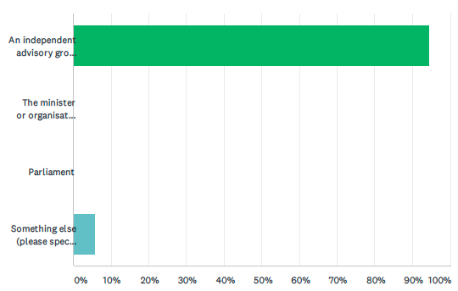

When voting on this question in the online questionnaire, we were each asked to give a brief reason for our answer. Reasons will be analysed and reported in the Juries’ Report in June.

We were also asked two further questions about the future of the data sharing initiative:
- What actions, if any, could be taken to engender greater public trust in the initiative? (Q2c)
- How could or should the initiative and its uses be usefully changed in the future (if at all)? (Q2d)
We worked together in groups to identify and prioritise our answers and reasoning to these questions. Our answers and most important reasons for those answers are set out in the two tables below.

Summary Care Record Additional Information - Future Changes
The use of Summary Care records has been enhanced during the pandemic for positive reasons such as developing rapid responses to Covid 19 and COPI has permitted the merging of the Additional Data and the Social Care Data. Providing all Lawful secure measures are met and the fundamental principles of data protection are revisited this should continue and records added through the additional information during COVID could be revisited to ensure only the minimum necessary data is contained going forward.
If these records can have real monetary value, the government could make law changes as to those who opt in and also agree can allow it to be legal to make money from scr record but only if monies made can be put directly back into NHS, help give pay rises to staff who deserve better pay. Not all agree, however, that this (or other data initiatives) should be monetized.
The Summary Care Records could have a more strict level of access as there are currently a lot of people who can access the data and data usage reports could be adopted or introduced. The list of healthcare professionals who can access SCR additional information is very broad.
Patients need to be fully informed about the SCR additional information so that public awareness about the initiative is improved and be able to access and correct any mistakes (like a credit file) to ensure clarity and that no mistakes are copied forward to other bodies of data.
The Summary Care Records can be improved by ensuring that the format and information captured is standardised and centralised so no relevant info is missed as at the present moment the referring GP or health professional may decide what information is important to include or note on a case-by-case basis.
Patients need to be given the clear chance to opt out if they don’t want to disclose their records as it is important everyone is offered the opportunity to opt out if they wish.
In the future, the Additional Info could be gathered through an opt-in process (as opposed to opt-out) although not all jurors agree this would be the ideal method and that it should be opt-out.

Summary Care Record Additional Information - Engender Public Trust
Every single person could be contacted via letter, email or other relevant platforms or media channels based on their personal preferences and communications methods and have the choice via a platform where they can opt out of different levels of personal data sharing based on how anonymised it is. This should be fully explained in plain English (not like other Terms & Conditions).
Action that could be taken to gain better public trust over the initiative could be in the form of better transparency and understanding that our scr are not yet standardised records, there is a discrepancy which lacks a true holistic approach where health and social care is concerned. Moving out of the pandemic improvements should be made to have a more complete record, so faster access, with correct information across all timelines of our lives, no lost notes and
Having specific authority figures given access to SCR to prevent data from being viewed by external sources doing this could be done to endanger public trust in this initiative because doing this could ensure the public safety to their data.
The Government could take additional steps to educate the public about this and other data initiatives or data uses through increased programming in schools, increased deliberative events and more coverage of these issues in Parliament and policy discussions.
In order to engender greater public trust in the initiative a simple message needs to be publicised. The: STAY HOME - SAVE LIVES has worked well and been a uniform message across all media. If all GOV.UK and NHS correspondence and communications displayed a consistent message e.g. DO YOU KNOW - WHAT WE KNOW - ABOUT YOU? Detailing where access can be found then perhaps more patients would become aware and therefore increase public trust.

Data Sharing Initiative: NHS Covid-19 Data Store and Platform

The data initiative being considered here is The Covid-19 NHS Data Store and Platform "ecosystem", including all the data flowing in and being processed by the Data Platform and associated products, and all the data flowing out. Patient-level and aggregated data flows into the Data Store and is de-identified and held within the Data Platform for use by many different products being used to tackle the pandemic. The products include the Early Warning System and Immunisation and Vaccination Management Capability sub-case studies (see sections 2.3 and 2.4 below). The whole “ecosystem” was created in 2020 in response to the pandemic. The legal basis for this data sharing initiative were the temporary provisions in the COPI Notices issued in 2020 (and subsequently renewed until September 2021).

Question 1 asks how supportive we were of the decision to introduce the data sharing initiative in Spring 2020. We voted on the multiple choice question (Q1a). We also identified and prioritised our reasons to support (Q1b) and oppose (Q1c) the data sharing initiative.

Q1 How supportive are you of the decision to introduce this data sharing initiative in 2020 as part of tackling the COVID-19 outbreak?

Answer choices | Responses | Percentage
Very much in support | 10 | 56%
Broadly supportive | 6 | 33%
Neutral | 1 | 5.5%
Broadly opposed | 1 | 5.5%
Very much opposed | 0 | 0%
TOTAL | 18 | 100%

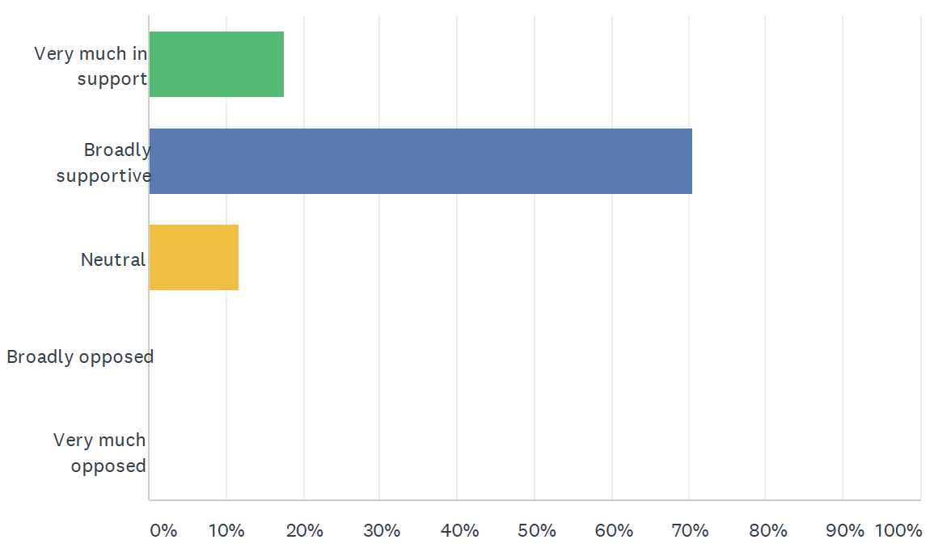

We also identified and prioritised our reasons to support (Q1b) and oppose (Q1c) the data sharing initiative.

Reasons to Support - COVID-19 Data Store and Platform
The Data Store and Platform allows strategic decision makers to view at a glance things that need to be immediately addressed (.ie Bed Capacity: PPE stock, etc.,) in order to coordinate COVID responses, manage resources, make more informed policy decisions, and tailor responses to local/regional needs. - 17 votes
The Data Store and Platform centralises all the data in one secure place which reduces duplication, improves efficiency, improves data quality, and reduces costs. - 11 votes
Lessons learned from the Data Store and Platform during COVID can help prepare for future pandemics. - 6 votes
The Data Store and Platform supports clinical research to better understand the virus, to help develop important treatments and vaccines, and to shape future research and other uses. - 9 votes
The Data Store and Platform has provided information to improve care and responses that have led to improved outcomes, better care, and saving lives. - 11 votes
Anonymised records are managed and stored securely in the Data Store and Platform. - 0 votes

Reasons to Oppose - COVID-19 Data Store and Platform
There has been a lack of transparency about the Data Store and Platform and poor communication with the public about what it is, how records are stored and shared, for what purposes, and no record of who is accessing data and why which could lead to further mistrust. - 16 votes
The number and types of corporations who have been contracted to build and implement the Data Store and Platform, along with uncertainties related to the contracts themselves and the procurement processes, may lead to the commercial use of records, uses for commercial gain, and potential misuse. - 10 votes
The process for obtaining explicit consent for the Data Store and Platform has not been adequate and people have not been given clear enough opportunity to opt-out of the initiative. - 12 votes
It is unclear how the Data Store and Platform will be used in the future and how/by whom these decisions will be made. - 6 votes
Contracts released by the NHS indicate that data within the Data Store and Platform may be applied for use cases outside of COVID-19. - 4 votes
Data enters the Data Store and Platform from a number of bodies that contribute to your record (NHS Digital, Public Health England, etc) and data could be wrong but still copied over into it without being corrected and with no way for the person affected being aware. - 2 votes
NHS England have not produced evidence to demonstrate the unique benefits of the Data Store and Platform. - 2 votes

Q2 What should the future of the data sharing initiative be?

We heard arguments from witnesses and then voted on two multiple choice questions about what we believe should be the future of the NHS Covid-19 Data Store and Platform.

Q2a: For how long should the initiative continue?

Answer choices | Responses | Percentage
As short a time as possible | 0 | 0%
Only as long as the Covid pandemic continues and emergency powers are in place | 8 | 44%
As long as it is valuable (potentially beyond the pandemic and for Covid and non-Covid uses) | 10 | 56%
Something else | 0 | 0%
TOTAL | 18 | 100%

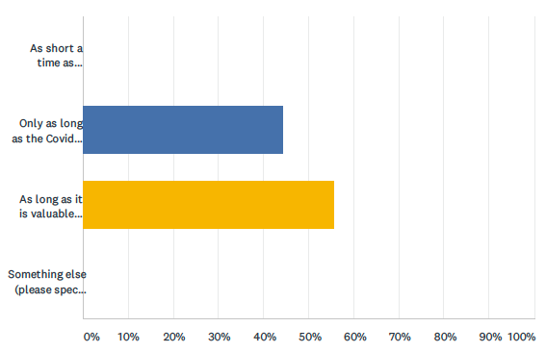
When voting on this question in the online questionnaire, we were each asked to give a brief reason for our answer. Reasons will be analysed and reported in the Juries’ Report in June.

Q2b: By whom should these decisions be made?

Answer choices | Responses | Percentage
An independent advisory group of experts and lay people | 11 | 61%
The minister or organisation accountable for the data initiative | 2 | 11%
Parliament | 4 | 22%
Someone else | 1 | 6%
TOTAL | 18 | 100%

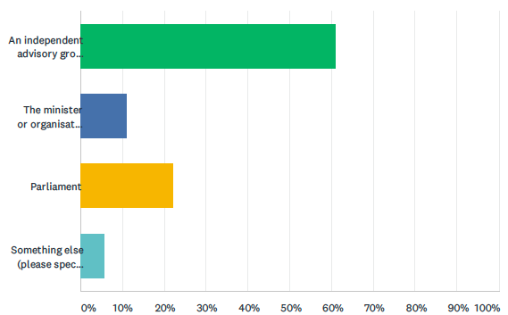

When voting on this question in the online questionnaire, we were each asked to give a brief reason for our answer. Reasons will be analysed and reported in the Juries’ Report in June.

We were also two further questions about the future of the data sharing initiative:
- What actions, if any, could be taken to engender greater public trust in the initiative? (Q2c)
- How could or should the initiative and its uses be usefully changed in the future (if at all)? (Q2d)
We worked together in groups to identify and prioritise our answers and reasoning to these questions. Our answers and most important reasons for those answers are set out in the two tables below.

Data Store and Platform - Future Changes
The information governance, DPIA and Privacy Notice documents need to be revised, adhered to and published for the data store and platform to ensure that the initiative is lawful, transparent and is processing the data in a safe way. This would then enable a broader use of the store and platform for BAU planning purposes, contingency seasonal planning and coordinating future vaccine programmes.
One way to usefully change the data store and platform for the future is to increase the level of communication with the public around the initiative. This is important because patients have a right to know what is being done to and with their data and, should the data store and platform continue post pandemic, effective communication will be key to gain people's trust in the initiative and keep trust in the NHS as a whole.
More action needs to be taken to make people aware that they do have the chance to opt out. The NHS could make people refrain from doing this by positively promoting how it has massively helped during the pandemic. Doing this will build trust between the public and their view on data sharing.
The initiative could be usefully changed by transferring to NHS Digital and becoming the Covid-19 disease register. This would ensure greater public trust due to the problematic and political connections of the companies involved and the reassurance that public / patient data and access to it was within a Safe Setting.
One way to usefully change the Data Store and Platform for the future is to increase the transparency of dealings between the NHS and Palantir / Amazon and other contractors with regards to the details of the contracts and the procurement processes between them and enable a review of these contracts and procurement processes. This is important as there are concerns around how Palantir may use the data in the future.
More democratic approach, such as a citizen jury could be conducted on a monthly basis so that the decision-making process is opened up to a diverse cross section of the public who could contribute their voice on these subjects.

Data Store and Platform - Engender Public Trust
One way to engender public trust in the data store and platform would be to gain opt in consent from patients as this would form a valid legal basis on which to use patient data. This is important because it means that patients would have clearly indicated their wish to be a part of the initiative and eliminates the most untrustworthy characteristic of the initiative in its current form, which is that the legal basis relies on COPI notices.
Forming an independent body to Govern the Data Store and Platform would engender greater public trust in the initiative. The Board members would approve access to the platform as well as approving and commissioning the projects that are initiated. The Board meetings and minutes would have to be published adding to the transparency of the process. As it would be an independent body this would help remove company bias.
Even though it states they have included a blog on the website regarding the platform, details regarding usage of the platform needs to be published, and monitored to establish where the data is being used, and for what needs so that it is more visible and easy to find for users.
Sending out text messages like the NHS has done in the past as well as sending out letters, similar to how poll cards are sent out. Using multiple methods of communication (such as social media, television, and other platforms) to inform the public of how their data is being used will engender public trust. Different ages should also be considered when campaigning public information and neutral role models such as relatable celebrities that can promote this information could be utilised as well.
One way to engender public trust would be to move it to a trusted research environment e.g. at NHS Digital under well established IG.

Data Sharing Initiative: Early Warning System
The data initiative being considered here is the Early Warning System, a product within the Covid-19 NHS Data Store and Platform "ecosystem". It uses data from the Data Platform to make forecasts about demands on the NHS in England. This is one of two sub-case studies we considered (the other being the Immunisation and Vaccination Management Capability – see section 2.4). For these sub-case studies, we had just two questions to answer: 1a and 2a.

Q1a How supportive are you of the decision to introduce this data sharing initiative in 2020 as part of tackling the COVID-19 outbreak?

Answer choices | Responses | Percentage
Very much in support | 10 | 56%
Broadly supportive | 8 | 44%
Neutral | 0 | 0%
Broadly opposed | 0 | 0%
Very much opposed | 0 | 0%
TOTAL | 18 | 100%

We each answered the above question along with an individual brief reason for our answer using an online questionnaire. Those free-text reasons will be analysed and reported in the Juries’ Report in June.

Q2a: For how long should the initiative continue?

Answer choices | Responses | Percentage
As short a time as possible | 1 | 5.5%
Only as long as the Covid pandemic continues and emergency powers are in place | 5 | 28%
As long as it is valuable (potentially beyond the pandemic and for Covid and non-Covid uses) | 11 | 61%
Something else | 1 | 5.5%
TOTAL | 18 | 100%

When voting on this question in the online questionnaire, we were each asked to give a brief reason for our answer. Reasons will be analysed and reported in the Juries’ Report in June.

Data Sharing Initiative: Immunisation and Vaccination Management Capability

The data initiative being considered here is the Immunisation and Vaccination Management Capability, a product within the Covid-19 NHS Data Store and Platform "ecosystem". It uses data from the Data Platform to help manage the implementation of vaccines in England. This is the second of the two sub-case studies we considered (the other being the Early Warning System – see section 2.3). For these sub-case studies, we had just two questions to answer: 1a and 2a.

Q1a How supportive are you of the decision to introduce this data sharing initiative in 2020 as part of tackling the COVID-19 outbreak?

Answer choices | Responses | Percentage
Very much in support | 15 | 83%
Broadly supportive | 2 | 11%
Neutral | 1 | 6%
Broadly opposed | 0 | 0%
Very much opposed | 0 | 0%
TOTAL | 18 | 100%

We each answered the above question along with an individual brief reason for our answer using an online questionnaire. Those free-text reasons will be analysed and reported in the Juries’ Report in June.

Q2a: For how long should the initiative continue?

Answer choices | Responses | Percentage
As short a time as possible | 0 | 0%
Only as long as the Covid pandemic continues and emergency powers are in place | 7 | 39%
As long as it is valuable (potentially beyond the pandemic and for Covid and non-Covid uses) | 10 | 55.5%
Something else | 1 | 5.5%
TOTAL | 18 | 100%

When voting on this question in the online questionnaire, we were each asked to give a brief reason for our answer. Reasons will be analysed and reported in the Juries’ Report in June.

Data Sharing Initiative: OpenSAFELY and its access to GP data

The data initiative being considered here is the software OpenSAFELY and specifically the access it currently provides to general practice (GP) data for research purposes. Researchers write and software queries to extract anonymised data directly from the GP patient electronic records. The legal basis for this data sharing initiative, and specifically for the access it is granted to GP electronic records, were the temporary provisions in the COPI Notices issued in 2020 (and subsequently renewed until September 2021).

Question 1 asks how supportive we were of the decision to introduce the data sharing initiative in Spring 2020. We voted on the multiple choice question (Q1a).

Q1 How supportive are you of the decision to introduce this data sharing initiative in 2020 as part of tackling the COVID-19 outbreak?

Answer choices | Responses | Percentage
Very much in support | 14 | 78%
Broadly supportive | 4 | 22%
Neutral | 0 | 0%
Broadly opposed | 0 | 0%
Very much opposed | 0 | 0%
TOTAL | 18 | 100%

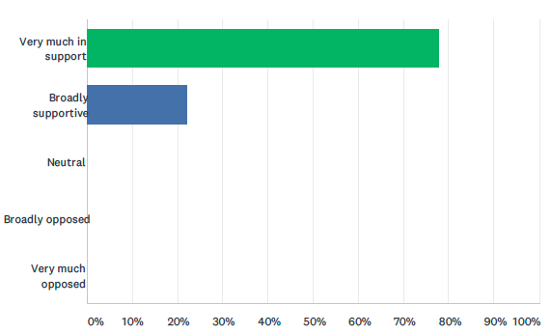

We also identified and prioritised our reasons to support (Q1b) and oppose (Q1c) the data sharing initiative.

Reasons to Support - OpenSAFELY
OpenSAFELY is more transparent than other initiatives as they have actively engaged with the media and public and are using a variety of methods (social media, a website, video and other materials) to inform the public. - 14 votes
OpenSAFELY is able to access 95% of patient records in order to provide quick responses to research queries which can lead to rapid findings, reliable (continuously updating) statistics, better research in the future, and benefits to our health system. - 14 votes
OpenSAFELY protects against misuse of the retrieved data via multi-level access, audit trails, publishing of code and no direct downloading or accessing of the data and publishing outputs (all of which is reviewed every three months). - 13 votes
OpenSAFELY allows for quick answers to specific queries and questions with real-time monitoring which helps inform policy making and improve COVID response decisions. - 9 votes
OpenSAFELY meets most of the “5 Safes” outlined by MedConfidential. - 3 votes

Reasons to Oppose - OpenSAFELY
Current legal basis (COPI notices) expires in September 2021 and it is unclear how OpenSAFELY will operate in the future (beyond the pandemic), and under what lawful basis it will do so, once current notices expire and if access to records changes for the remainder of its planned 3-year duration. - 15 votes
Current decision making (eg research decisions under the authority of the Chief Medical Officer) and governance model potentially exposes the research to significant bias and reduces transparency. - 11 votes
Although OpenSAFELY did respect patients who opted out in their GP records, patients were not given an explicit opportunity to opt out of this specifically (meaning patients didn’t actively give permission for their data to be used for COVID-19 research). - 10 votes
OpenSAFELY could do more to make the public aware of what it is, how it accesses patient records, and how it operates (such as Data Privacy Impact Assessments or other documentation). - 8 votes
OpenSAFELY could be utilised for commercial purposes or commercial gain or move towards a commercial model rather than being used for public benefit research. - 5 votes
OpenSAFELY meets most, but not all, of the Five Safes and would need to be modified to do so. - 3 votes

Q2 What should the future of the data sharing initiative be?

We heard arguments from witnesses and then voted on two multiple choice questions about what we believe should be the future of the access provided to GP records by OpenSAFELY.

Q2a: For how long should the initiative continue?

Answer choices | Responses | Percentage
As short a time as possible | 0 | 0%
Only as long as the Covid pandemic continues and emergency powers are in place | 1 | 5.5%
As long as it is valuable (potentially beyond the pandemic and for Covid and non-Covid uses) | 16 | 89%
Something else | 1 | 5.5%
TOTAL | 18 | 100%
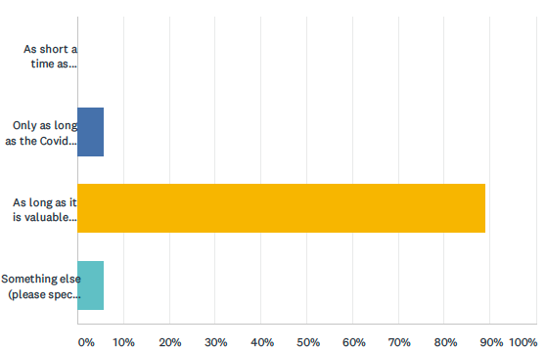
When voting on this question in the online questionnaire, we were each asked to give a brief reason for our answer. Reasons will be analysed and reported in the Juries’ Report in June.

Q2b: By whom should these decisions be made?

Answer choices | Responses | Percentage
An independent advisory group of experts and lay people | 15 | 83%
The minister or organisation accountable for the data initiative | 1 | 6%
Parliament | 0 | 0%
Someone else | 2 | 11%
TOTAL | 18 | 100%

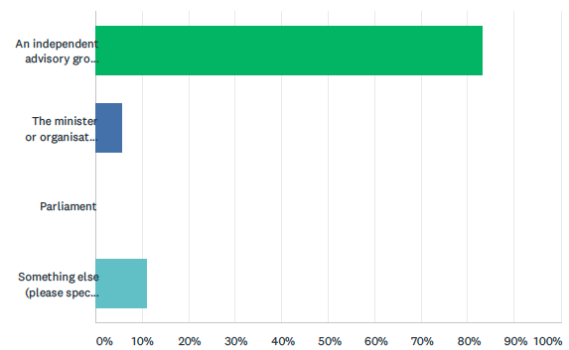

When voting on this question in the online questionnaire, we were each asked to give a brief reason for our answer. Reasons will be analysed and reported in the Juries’ Report in June.

We were also two further questions about the future of the data sharing initiative:
- What actions, if any, could be taken to engender greater public trust in the initiative? (Q2c)
- How could or should the initiative and its uses be usefully changed in the future (if at all)? (Q2d)
We worked together in groups to identify and prioritise our answers and reasoning to these questions. Our answers and most important reasons for those answers are set out in the two tables below.

OpenSAFELY - Future Changes
OpenSafely should find a legal standing to replace COPI for post-pandemic use so that the implied or explicit consent (depending on legal mechanism) is there, and the public is given the option to explicitly opt-out if they wish. This will help the initiative to rely on public acceptance, good governance, and fixed parameters.
Because the initiative uses realtime information/records, if it is to continue after covid, the decision to continue using this data should be reached after a public consultation.
The initiative should get rid of the Chief Medical Officer making decisions without appointed advisors; there should instead be an executive board to reduce conscious/unconscious bias and to increase the democratic nature of the initiative.
OpenSAFELY could publish the terms and conditions of the contracts they were/are awarded by the government.
The OpenSAFELY platform could be modified or adapted to replace other data initiatives in a safe and transparent way without accessing the data or records directly (ie hospital records).
OpenSAFELY needs functional IG and transparency processes, and to be under the data controllership of the statutory safe haven, ie NHS Digital

OpenSAFELY - Engender Public Trust
Publicly publish the data use practices, use, and applications of OpenSAFELY (the “who, when, what, why, and how”).
Support a public campaign that alerts the public to OpenSAFELY, and engage people like the Prime Minister and Matt Hancock, or even more neutral parties, to participate in the dissemination of information about the initiative.
Have public elections to designate who will oversee the initiative.
Obtain legal standing for OpenSAFELY after COPI notices run out.
Give people a chance to exercise their right to opt out of post-pandemic secondary uses of their data and inform them of significant changes that occurred during the pandemic.

After considering each data sharing initiative, we were asked to consider a final question:

Q3 What lessons could be learned for the future?

The first part of the question concerned lessons for future pandemics and the second part was around lessons learned which could be useful outside of pandemics. We worked together in groups to identify and prioritise our answers and reasoning to these questions.

Lessons for Future Pandemics
In preparation for future pandemics there needs to be clear strategies to activate data sharing initiatives in real time which will enable supply chain management and coordination of resources, research, medical responses, etc. to be ready in situ in order to allow health services to be primed and ready to deliver appropriate healthcare to patients and reduce the impact of a pandemic.
A lesson learnt that could be important in future pandemics is to be specific and communicate effectively with the public about what data is being collected or used, why it is being collected or used and what are the proposed outputs. This documentation can be standardised and a template devised to be used and published to ensure greater public transparency.
The most important thing to learn from how the pandemic data initiatives were introduced is to ensure opt-in consent for use of patient data as soon as or whenever realistically possible. The decision as to how soon is soon enough should rest with independent experts. The only scenario in which it is okay to use patient data without absolute opt-in consent is if needed to save a significant number of lives and patients should then be able to opt-out if they wish.
It will be important to learn from and along with other countries in order to prepare for future pandemics and to prepare a response that allows the UK to respond more quickly, with less confusion, and more effectively to future pandemics and be a leader in the global response.
A nonpartisan, non parliamentary group could be independently responsible for conducting a review of pandemic preparation in order to ensure that plans are properly financed and enacted in the best interests of the population.

Lessons for Future Outside Pandemics
The five safes should be adhered to (safe people, safe data, safe projects, safe settings and safe outputs) for our data to provide security and better transparency about uses of our data to help the public make informed choices and understand who is using our information and for what purposes.
Real-time anonymous data sharing could be used in the future of Smart Cities, i.e. traffic management and electricity grids, etc. In terms of health, the benefits to the individual patients are that clear, up-to-date and full information is accessible to any healthcare professional they may need to visit, making healthcare more safe and reliable.
The emphasis on data and research informed practice has kept a focus on public health, in particular health inequalities. This must be sustained to improve health outcomes for all citizens in a truly democratic society that claims to wish to ‘level up’.
A lesson that has been learnt that would be useful outside of a pandemic would be for NHS England / Digital / NHS X / NHS Improvement to have a published data catalogue (just fields not data) of all the datasets they have access to and what the linking identifiers are. This can be three-fold as it will enable greater public transparency, it will help target research and help to define the specific research questions and it can help platforms such as OpenSAFELY run on top of the datastore so they can extract the aggregated data needed for research.
The information gathered about the vulnerability to Covid of people in certain groups including age, ethnicity, socio economic and gender could be used to improve the general health of the nation by focusing NHS resources where they were most needed and be fairer.
We need to give some serious thought to informed consent. The pandemic has made some great strides forwards in increasing and improving partnership working and data sharing across the board - that is something to celebrate. There is another side to that too - as more and more people will be impacted over the next couple of years due to economic and well being effects which may require more help and support it feels important that when the general public consent to share their records they fully understand what that means; who has access to their data; and understand their right to opt out without feeling that this will have a potentially detrimental impact on access to services such as insurance, right to stay, housing etc.,.
Outside of a pandemic it would be reassuring for the public to have data initiatives be as transparent with them as possible, so for example if your data/records were accessed whether it be for a referral or statistical use. Patients could receive an automated text or other notification which states when it was accessed and by who, and a brief statement explaining what it is referencing. And if the individual deems it unnecessary or wants to flag it up they should be able to via a link on the notification. There should also be a method of authentication for this process.

The jury process: what we heard and did

This section provides an overview of what we did over the eight days of the citizens’ jury: from 13.00 to 17.30 each day on 16-19 March, and then from 22-25 March 2021. We heard from a range of expert witnesses. We asked questions and collectively captured important information after each presentation. The briefs given to each presenter and their slides will be published online when the set of three citizens’ juries are complete.

Jury Day 1: Context setting

The event began with introductions by jury members, and to the citizens’ jury process and deliberation. This was led by the process designers and facilitators Kyle Bozentko and Sarah Atwood from the Center for New Democratic Processes (formerly Jefferson Center).

We then heard from Dr Alan Hassey, a former GP and health informatician. He was briefed to address the question: “what are patient and care records and how are they used?”.

Jury Day 2: Background information

Peter Singleton, a consultant specialising in health information governance, began the day with a presentation addressing the question: “what are the normal rules for using and protecting patient records?”.

Peter Singleton then gave a second presentation addressing the question: “How did the normal rules change for the pandemic?”.

The final presentation was from Prof David Harper, Senior Consulting Fellow at Chatham House. He was briefed to present on: “planning for pandemics”.

Jury Day 3: Summary Care Record Additional Information

Day 3 was devoted to this data sharing initiative. The first presentation was delivered jointly by Dr Robert Jeeves, GP Lead for Summary Care Record, NHS Digital (neutral content) and John Farenden, Senior Programme Lead, Shared Records Programme, NHSX (persuasive content).

Phil Booth, medConfidential co-ordinator, was briefed to raise concerns and challenges about the data sharing initiative.

Jury Day 4: NHS Covid-19 Data Store and Platform

Day 4 was devoted to this data sharing initiative. The first presentation (both neutral and persuasive content) was delivered by Ming Tang, National Director Data and Analytics at NHS England and NHS Improvement.

Phil Booth, medConfidential co-ordinator, was briefed to raise concerns and challenges about the data sharing initiative.

Jury Day 5: Early Warning System and Immunisation and Vaccination Management Capability

On Day 5 we considered two sub-case studies: firstly, the Early Warning System and then the Immunisation and Vaccination Management Capability. These two data sharing initiatives are products within the NHS Covid-19 Data Store and Platform “ecosystem”.

The first Early Warning System presentation was delivered jointly by Ed Kendall, Deputy Director for Economics (neutral content) and Dr Harrison Carter, National Medical Director’s Clinical Fellow (persuasive content), both from NHS England and NHS Improvement.

Phil Booth, medConfidential co-ordinator, was briefed to raise concerns and challenges about the Early Warning System data sharing initiative.

The first Immunisation and Vaccination Management Capability presentation was delivered by Ayub Bhayat, Director of Insights and Data Platform Capability from NHS England and NHS Improvement.

Phil Booth, medConfidential co-ordinator, was briefed to raise concerns and challenges about the Immunisation and Vaccination Management Capability data sharing initiative.

Jury Day 6: OpenSAFELY

Day 6 was devoted to this data sharing initiative. The first presentation (both neutral and persuasive content) was delivered by Jess Morley, Policy Lead, University of Oxford’s DataLab.

Phil Booth, medConfidential co-ordinator, was briefed to raise concerns and challenges about the data sharing initiative.

Jury Day 7: Jury Deliberations

On day 7, we worked together to further develop our thinking about the data sharing initiatives, and lessons learned for the future.

Jury Day 8: Deliberation and report writing (this report)

On the final jury day, we had further deliberations, voted on jury questions, and worked on and agreed the contents of this report.

Appendix A: Messages to our neighbours

When asked about what they would want to share with their family, friends, and neighbours about their experience on the jury, participants shared the following:

Appendix B: The jury questions

The three citizens’ juries all consider the same set of questions.

The juries will consider three pandemic data initiatives which were introduced or substantially changed in response to Covid-19::
- Summary Care Record (which was extended to include more data about patients during the pandemic)
- NHS Covid-19 Data Store (which was created in response to the pandemic)
- OpenSAFELY (which uses primary care data for research).

For each initiative, the jury will address the following questions:

- a) How supportive are you of the decision to introduce this data sharing initiative in 2020 as part of tackling the COVID-19 outbreak?
Very much in support/ Broadly supportive/ Neutral/ Broadly opposed/ Very much opposed

- “What are the most important reasons to be supportive?”
- “What are the most important reasons to oppose the initiative?”

- What should the future of the data sharing initiative be?
  - For how long should the initiative continue
    - As short a time as possible
    - Only as long as the Covid pandemic continues and emergency powers are in place
    - As long as it is valuable (potentially beyond the pandemic and for Covid and non-Covid uses)
    - Something else

  - By whom should these decisions be made?
    - An independent advisory group of experts and lay people
    - The minister or organisation accountable for the data initiative
    - Parliament
    - Someone else

  - How could or should the initiative and its uses be usefully changed in the future (if at all)?
  - What actions, if any, could be taken to engender greater public trust in the initiative?
  - What are the main reasons for these answers?

At the end of each jury, the jury will be asked:
- What lessons can we learn from how these pandemic data initiatives were introduced
  - which could be useful for future pandemics?
  - which could be useful outside of pandemics?

There are also two “sub-case studies” for the jury to consider. These are systems reliant on the NHS Covid-19 Data Store:
- The Early Warning System
- The Immunisation and Vaccination Management (I&V) Capability.

The juries will answer two of the above questions about each of these sub-case studies: 1 a) and 2a).

Emergency powers are in place to deal with the pandemic, see: https://www.instituteforgovernment.org.uk/explainers/emergency-powers

